Ford Registration System

Software Requirements Specification

Chris Ciolek

Nicholas Spencer

Maxx Achtman

Apolonio Cazares

# Table of Contents

**Table of Contents** **1**

**Introduction (WIP)** **4**

Goals and Objectives 4

Statement of Scope 4

Functional Requirements 4

Non-Functional Requirements 4

Hardware Requirements 5

Software Requirements 5

Inverse Requirements 5

Deliverables: 5

Software Context 5

Major Constraints 6

**Usage Scenario** **6**

User Profiles 6

Use Story Descriptions 7

Register as Evaluator 7

Register as Supplier/Presenter 7

Modify Registration 7

Sign Waiver 8

Fill Registration Form 8

Confirm Registration 8

Log In to Admin Panel 8

Print Attendee Badges 9

Send Email 9

Open/Close Event Registration 9

Add/Remove Event Dates 9

Check in Attendee 9

Add/Remove Technology Category 10

Add/Remove Technology 10

Add/Remove Admin Account 10

Edit Admin Accounts 10

Generate Badge Sheet 11

Generate QR Code 11

Special Usage Considerations 11

Work within the confines of Ford’s internal security system 11

**Data Model and Description** **11**

Data Objects 11

Relationships 14

Data Model 15

**Functional Model and Description** **15**

Description for Function n (PSPEC) 15

Register as Evaluator 15

Register as Supplier/Presenter 16

Modify Registration 17

Sign Waiver 17

Fill Registration Form 17

Confirm Registration 18

Log In to Admin Panel 18

Print Attendee Badges 19

Send Email 19

Open/Close Event Registration 19

Add/Remove Event Dates 20

Check in Attendee 20

Add/Remove Technology Category 20

Add/Remove Technology 21

Add/Remove Admin Account 21

Edit Admin Accounts 22

Generate Badge Sheet 22

Generate QR Code 23

Software Interface Description 23

Activity Diagrams for Core Functionality 24

Attendee Registration 24

Modify Registration 25

Checking in Attendee 25

Add Event Date 26

Print Attendee Badges 27

**Behavioral Model and Description** **27**

Description for Software Behavior 27

Events 27

States 28

State Transition Diagrams 28

Control Flow Description 30

**Restrictions, Limitations, and Constraints** **32**

**Validation Criteria** **32**

Classes of Tests 32

Expected Software Response 33

Performance Bounds 34

**Appendices** **35**

System Traceability Matrix 35

Product Strategies 36

Analysis metrics to be used 36

# 

# 

# 

# Introduction (WIP)

## Goals and Objectives

The goal for this software is to allow for users to select dates and register to be a participant in Fords IDTE event, and receive confirmation emails regarding the event. Additionally, each user will have a generated QR code on their ticket that will let them check in when they arrive at the IDTE.

## Statement of Scope

### Functional Requirements

* + - 1. User can register as a supplier, presenter, or evaluator
      2. A waiver needs to be signed before a user can sign up to attend the event
      3. Attendees for the event can modify their registration at any point before an event
      4. Administration confirms a registration from a requested attendee
      5. Administration can view how many attendees there would be on a given day for the event
      6. A superadmin would be created that can have access to administrative accounts
      7. Administration can change dates of events
      8. Administration can open or close the registration dates for events
      9. Email that is sent to the attendee contains a QR code with their information provided during registration
      10. Badges would be printed on the day of the event by administration

### Non-Functional Requirements

* + - 1. Application can run on mobile
      2. Application can run on any web browser
      3. Database is secure and cannot be accessed outside of select individuals
      4. User information for attendees can only be viewed by their own person
      5. Information stored in database is only for IDTE

### Hardware Requirements

* + - 1. Windows OS
      2. Mac OS
      3. Web camera
      4. Mobile Phone

### Software Requirements

* + - 1. Node.Js
      2. HTML
      3. CSS
      4. JavaScript
      5. Java
      6. Sqlite

### Inverse Requirements

* + - 1. N/A

### Deliverables:

Inputs:

* User credentials (Front end)
  + First Name
  + Last Name
  + Email Address
  + Association with event
  + Dates to attend event

Processing:

* Data from inputs to database
* Generate QR code

Output:

* Email sent to user with QR code

## Software Context

This web based application would allow users to register for the IDTE event hosted by Ford. A user would have to first access the website and sign a waiver. Once that is completed, the user would then register for the event by providing the necessary information as requested for the database system. Upon completion, the user would be sent an email with a generated QR code that would be presented upon the day of the event.

## Major Constraints

Time frame for release of product.

# Usage Scenario

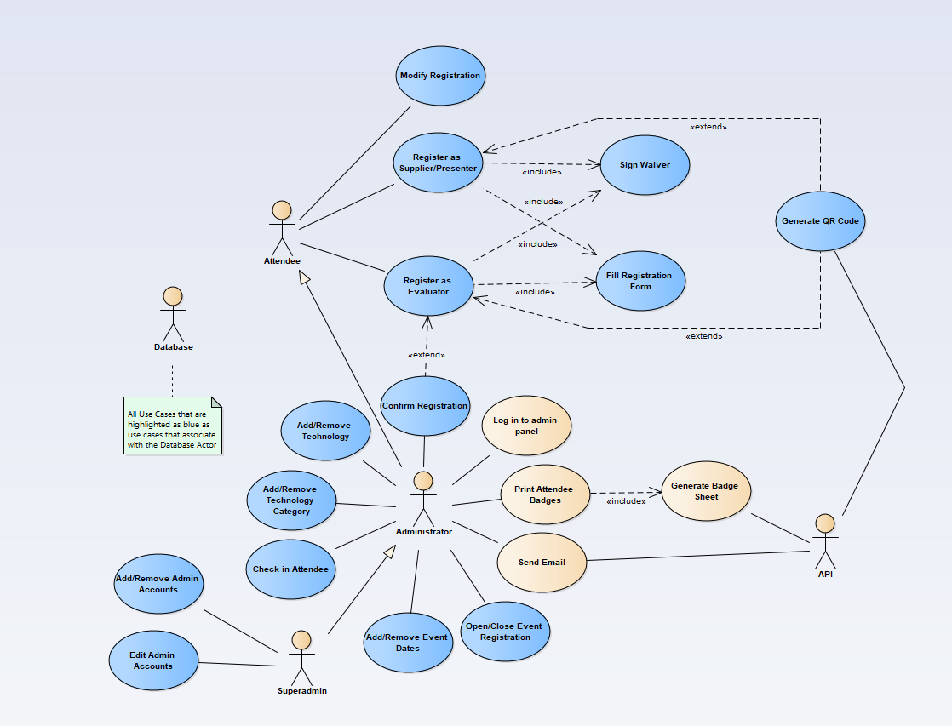

## User Profiles

* + 1. Attendees
       1. Attendees should be able to register for the event and to modify their registration information
    2. Administrators
       1. Administrators are responsible for handling the list of registered attendees, managing the technologies and associated categories, checking in attendees and printing badges, managing event dates, managing event registration availability, sending emails, and logging into the administrative panels
    3. Superadmins
       1. Superadmins can do everything administrators can do, but superadmins can also manage administrative accounts
    4. API
       1. The API handles all database connections, as well as some backend processing tasks such as generating QR codes, generating the printable badge sheets, and sending out emails as the administrators writes them
    5. Database
       1. The database is responsible for storing data to be used in any of the other use cases

## Use Story Descriptions

## Register as Evaluator

* + - 1. **Primary Actor**: Attendee / User.
      2. **Preconditions**: User is on website interface.
      3. **Description**: User chooses to register as an Evaluator on the Main menu, then proceeds to fill out the registration form. Before registration is complete the User must receive confirmation from an admin.
      4. **Acceptance Criteria**: User is successfully registered and confirmed as an evaluator.

## Register as Supplier/Presenter

* + - 1. **Primary Actor**: Attendee / User.
      2. **Preconditions**: User is on website interface.
      3. **Description**: User chooses to register as a supplier or presenter on the Main menu, then proceeds to fill out the registration form.
      4. **Acceptance Criteria**: User is successfully registered as a supplier or presenter.

## Modify Registration

* + - 1. **Primary Actor**: Attende / Admin / User.
      2. **Preconditions**: User is on website interface.
      3. **Description**: User chooses to modify an existing registration. User searches for themself and then proceeds to make changes to their own registration.
      4. **Acceptance Criteria**: User modifications are completed and successfully stored.

## Sign Waiver

* + - 1. **Primary Actor**: Attendee / User.
      2. **Preconditions**: User is on website and started the registration process.
      3. **Description**: User starts registration and before they can fill out the form they are required to read and sign the provided waiver.
      4. **Acceptance Criteria**: User has read and signed the waiver.

## Fill Registration Form

* + - 1. **Primary Actor**: Attendee / User.
      2. **Preconditions**: User is on website and started the registration process. User has Signed the waiver.
      3. **Description**: User signed waiver and continued to the registration form. User fills out this form correctly and submits.
      4. **Acceptance Criteria**: Registration is correctly entered and successfully submitted.

## Confirm Registration

* + - 1. **Primary Actor**: Administrator / Admin.
      2. **Preconditions**: A user has attempted to register as an evaluator and the Admin has logged in.
      3. **Description**: Administrator looks over evaluator registration form and verifies the information.
      4. **Acceptance Criteria**: Evaluator registration form is reviewed and a decision is made whether the registration is valid or not.

## Log In to Admin Panel

* + - 1. **Primary Actor**: Administrator / User.
      2. **Preconditions**: User has navigated to website home.
      3. **Description**: User enters their credentials into the login fields. Credentials are verified.
      4. **Acceptance Criteria**: User is logged into the website as an admin and now has access to admin functionality.

## Print Attendee Badges

* + - 1. **Primary Actor**: Administrator / Admin.
      2. **Preconditions**: Administrator is logged in.
      3. **Description**: Administrator chooses which group or individual to print a badge for. Badges are printed.
      4. **Acceptance Criteria**: Badges for selected group are printed successfully.

## Send Email

* + - 1. **Primary Actor**: Administrator / Admin.
      2. **Preconditions**: Admin wants to send an email to a selection of attendees. Admin is logged in.
      3. **Description**: Administrator selects option to send email and then selects which group/individual to send an email to. Admin then sends the email.
      4. **Acceptance Criteria**: Email is received by the target audience.

## Open/Close Event Registration

* + - 1. **Primary Actor**: Administrator / Admin.
      2. **Preconditions**: Admin wants to stop or start allowing users/attendees to register for the event. Admin is logged in as admin.
      3. **Description**: Administrator selects option to open/close the registration. Then admin chooses the option they like
      4. **Acceptance Criteria**: Email is received by the target audience.

## Add/Remove Event Dates

* + - 1. **Primary Actor**: Administrator / Admin.
      2. **Preconditions**: Admin wants to create/remove events that are available to sign up for. Admin is logged in as admin.
      3. **Description**: Administrator selects option to add/remove the registration. Then admin chooses the option they like and fills out required information.
      4. **Acceptance Criteria**: Event is successfully created and users can register for it, or event is successfully removed.

## Check in Attendee

* + - 1. **Primary Actor**: Administrator / Admin.
      2. **Preconditions**: Attendee has arrived for event. Admin is logged in.
      3. **Description**: Administrator selects option to check in an attendee. Then the admin opens the web interface and checks in the Attendee via using a camera for the QR code, or searching the attendee by name.
      4. **Acceptance Criteria**: Attendee QRcode/Registration info is identified and the Attendee is able to go to the event.

## Add/Remove Technology Category

* + - 1. **Primary Actor**: Administrator / Admin.
      2. **Preconditions**: New technology needs to be added or removed. Admin is logged in.
      3. **Description**: Administrator selects option to add/remove a technology category. Technology category information is filled in. New technology category added or old technology category is deleted.
      4. **Acceptance Criteria**: Technology category is now part of list or not on list anymore.

## Add/Remove Technology

* + - 1. **Primary Actor**: Administrator / Admin.
      2. **Preconditions**: New technology category needs to be added or removed. Admin is logged in.
      3. **Description**: Administrator selects option to add/remove a technology. Technology information is filled in. New technology added or old technology is deleted.
      4. **Acceptance Criteria**: Technology is now part of list or not on list anymore.

## Add/Remove Admin Account

* + - 1. **Primary Actor**: Superadmin.
      2. **Preconditions**: Superadmin is logged in.
      3. **Description**: Superadmin chooses to add or remove admin accounts. Account information is filled out. Account gets added or removed.
      4. **Acceptance Criteria**: New admin account exists or old admin account does not exist.

## Edit Admin Accounts

* + - 1. **Primary Actor**: Superadmin.
      2. **Preconditions**: Superadmin is logged in. Admin accounts exist to be edited.
      3. **Description**: Super admin chooses to edit admin accounts. Account id/name is entered. New account form is filled out.
      4. Acceptance Criteria: Modifications are successfully saved on the account.

## Generate Badge Sheet

* + - 1. **Primary Actor**: Administrator / API.
      2. **Preconditions**: Accounts exist in order to print badges. Admin is logged in.
      3. **Description**: Administrator selects option to print attendee badges. Upon printing, the API generates a Badge sheet of the selected group.
      4. **Acceptance Criteria**: Badge sheet is generated correctly.

## Generate QR Code

* + - 1. **Primary Actor**: API.
      2. **Preconditions**: Attendee has registered.
      3. **Description**: Attendee registers. API generates a unique QR code for the new attendee and stores it.
      4. **Acceptance Criteria**: QR code is unique and correct.

## Special Usage Considerations

## Work within the confines of Ford’s internal security system

# Data Model and Description

## Data Objects

* + 1. Relationships
    2. Data Model

# Functional Model and Description

## 

## Software Interface Description

# Behavioral Model and Description

# Restrictions, Limitations, and Constraints

# Validation Criteria

# Appendices

## System Traceability Matrix

|  |  |  |  |  |  |  |  |  |  |  |
| --- | --- | --- | --- | --- | --- | --- | --- | --- | --- | --- |
| U/R | R1 | R2 | R3 | R4 | R5 | R6 | R7 | R8 | R9 | R10 |
| US1 | X | X |  |  |  |  |  |  |  |  |
| US2 | X | X |  |  |  |  |  |  |  |  |
| US3 |  |  | X |  |  |  |  |  |  |  |
| US4 |  | X |  |  |  |  |  |  |  |  |
| US5 | X | X |  |  |  |  |  |  |  |  |
| US6 | X | X |  | X |  |  |  |  |  |  |
| US7 |  |  |  | X | X |  | X |  |  |  |
| US8 |  |  |  |  |  |  |  |  |  | X |
| US9 |  |  |  |  |  |  |  |  | X |  |
| US10 |  |  |  |  |  |  |  | X |  |  |
| US11 |  |  |  |  |  |  | X |  |  |  |
| US12 |  |  |  |  |  |  |  |  | X | X |
| US13 |  |  |  |  |  |  | X | X |  |  |
| US14 |  |  |  |  |  |  | X | X |  |  |
| US15 |  |  |  |  |  | X |  |  |  |  |
| US16 |  |  |  |  |  | X |  |  |  |  |
| US17 |  |  |  |  |  |  |  |  | X |  |
| US18 |  |  |  |  |  |  |  |  | X |  |

## Product Strategies

## Analysis metrics to be used

# 

|  |  |  |  |
| --- | --- | --- | --- |
| Review and Signoff of the Software Requirements Specification | | | |
| LAST NAME | FIRST NAME | SIGNATURE | DATE |
| Achtman | Maxx |  |  |
| Ciolek | Christopher |  |  |
| Spencer | Nicholas |  |  |
| Cazares | Apolonio |  |  |
| Belwafa | Jamel |  |  |
|  |  |  |  |
|  |  |  |  |